Question no 5 Implement a test SCD2 table in BQ, explain about the SCD2 tables

So based in this [article](https://medium.com/happiestneurons/slowly-changing-dimension-type-2-scd2-in-big-query-95330ce31625), there are 2 type of SCD. SCD type 2 : Maintains dimension history by creating newer ‘versions’ of a dimension record whenever its source changes. SCD2 does not delete or modify existing data. Basically when the source data changes you expire the existing record in the dimension table via an indicator (boolean or date or any standard technique of marking a record as expired by setting a flag)

Simple explain of SCD type 2 is for illustration there are 2 table product and staging_product in bigquery. So we want insert new data from staging_product table to product table. After insert new data, product table insert new record

Product_staging table

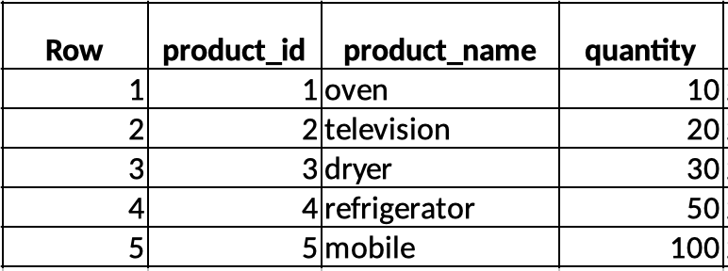

Product table before merge

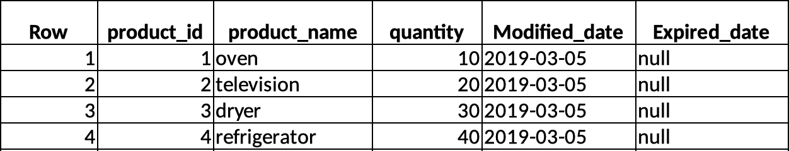

Product table after merge

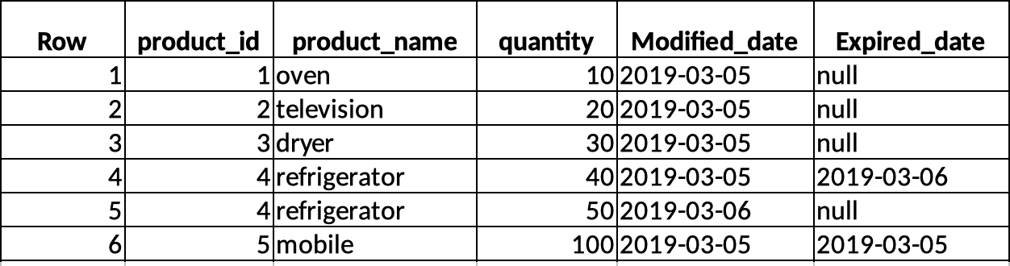

The query is bellow :

MERGE INTO

`aerial-anagram-273815.merge_table.product`

USING

(

#the base staging data.

SELECT

`aerial-anagram-273815.merge_table.product_staging`.product_id AS join_key,

`aerial-anagram-273815.merge_table.product_staging`.*

FROM

`aerial-anagram-273815.merge_table.product_staging`

UNION ALL

#generate an extra row FOR changed records.

#the NULL join_key forces records down the INSERT path.

SELECT

NULL,

`aerial-anagram-273815.merge_table.product_staging`.*

FROM

`aerial-anagram-273815.merge_table.product_staging`

JOIN

`aerial-anagram-273815.merge_table.product`

ON

`aerial-anagram-273815.merge_table.product_staging`.product_id = `aerial-anagram-273815.merge_table.product`.product_id

WHERE

( `aerial-anagram-273815.merge_table.product_staging`.quantity <> `aerial-anagram-273815.merge_table.product`.quantity

AND `aerial-anagram-273815.merge_table.product`.expired_date IS NULL)) sub

ON

sub.join_key = `aerial-anagram-273815.merge_table.product`.product_id

WHEN MATCHED AND sub.quantity <> `aerial-anagram-273815.merge_table.product`.quantity THEN UPDATE SET expired_date = CURRENT_DATE()

WHEN NOT MATCHED

THEN

INSERT

( product_id,

product_name,

quantity,

modified_date,

expired_date )

VALUES

( sub.product_id, sub.product_name, sub.quantity, CURRENT_DATE(), NULL );